**Steps for checking Study details**

Step 01: Login using crdr.phfi.org.

Using your credentials given login in to the application.

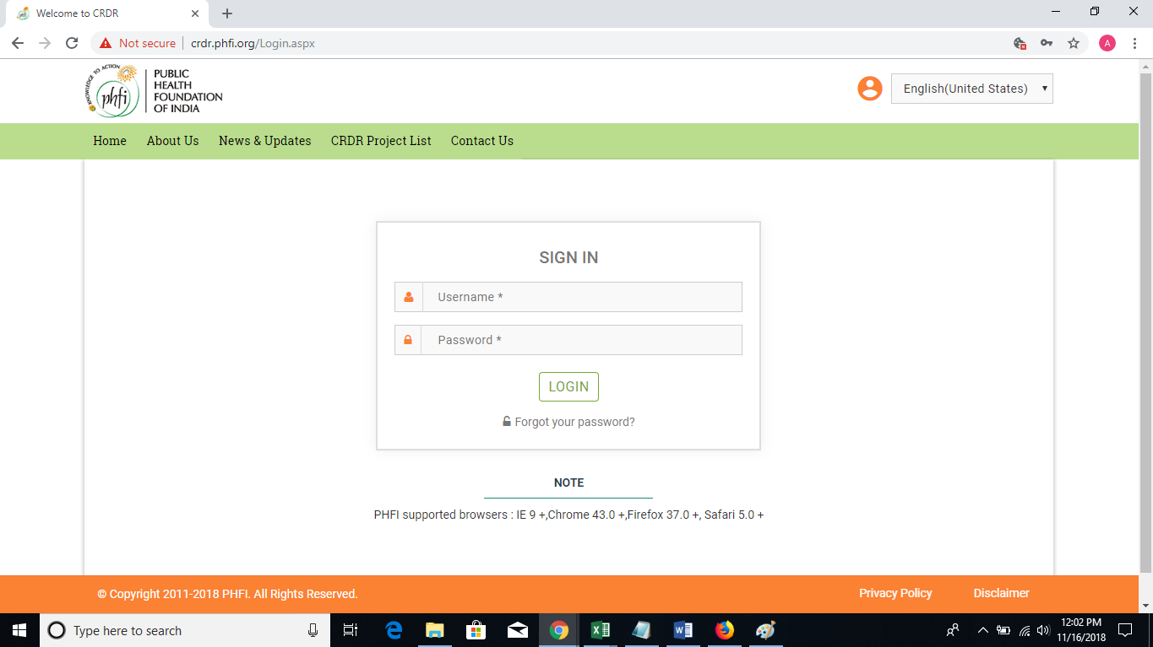

Step 02: You will be navigated to Mange studies page. Where the list of the studies will be displayed with various options.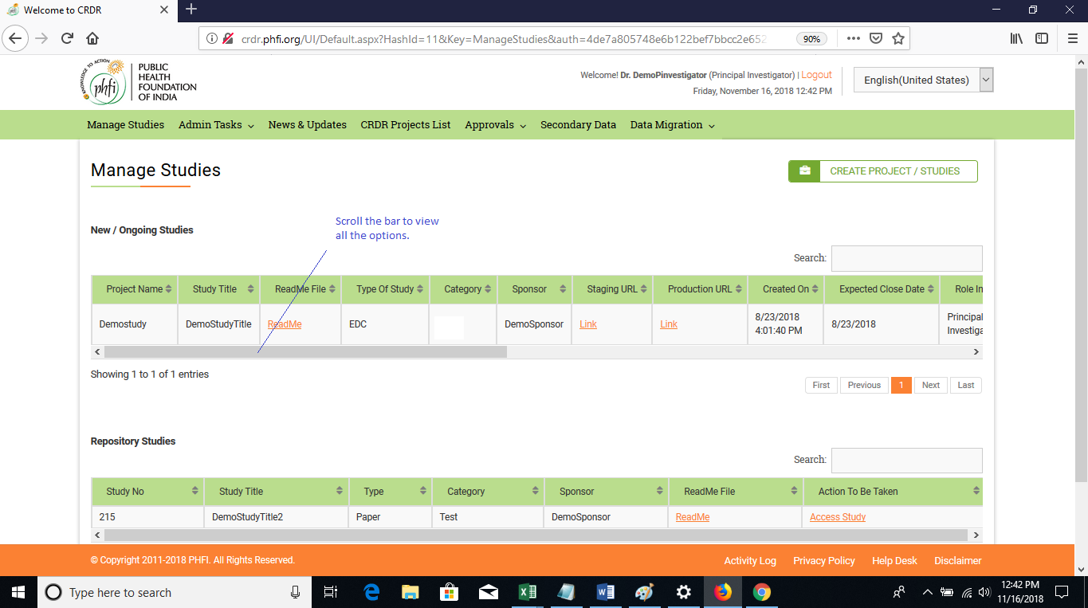

Step 03: using scrollbar view all the options and you will find the DMS option to upload and check the already uploaded files.

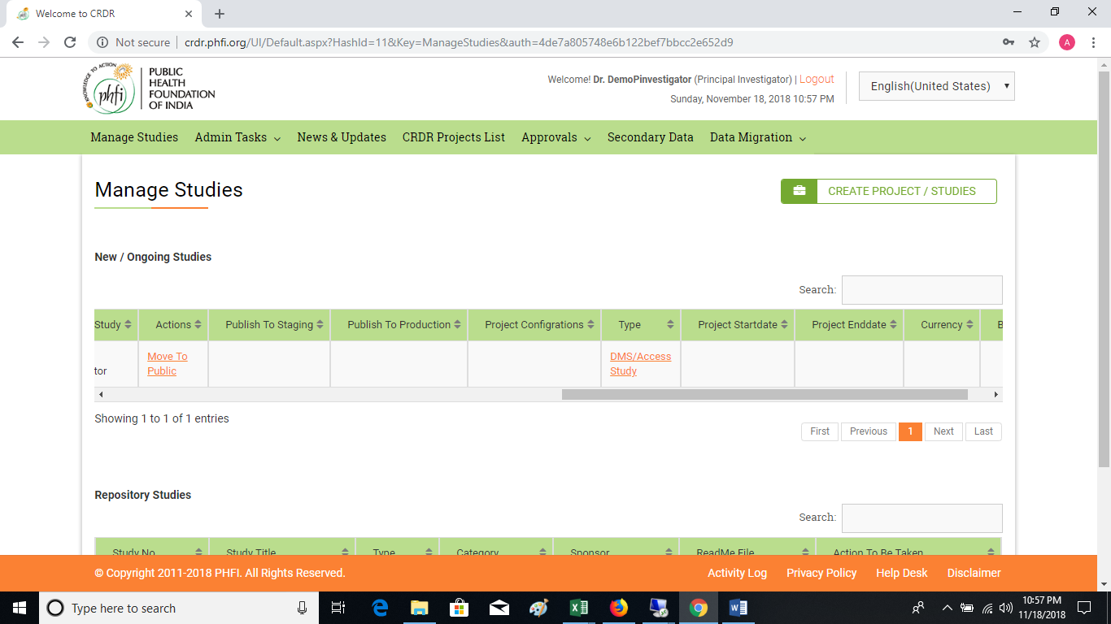

Step 04: To check the Migrated data. Click open on **DataMigration** andhovermouseon **“Study data preview”.**

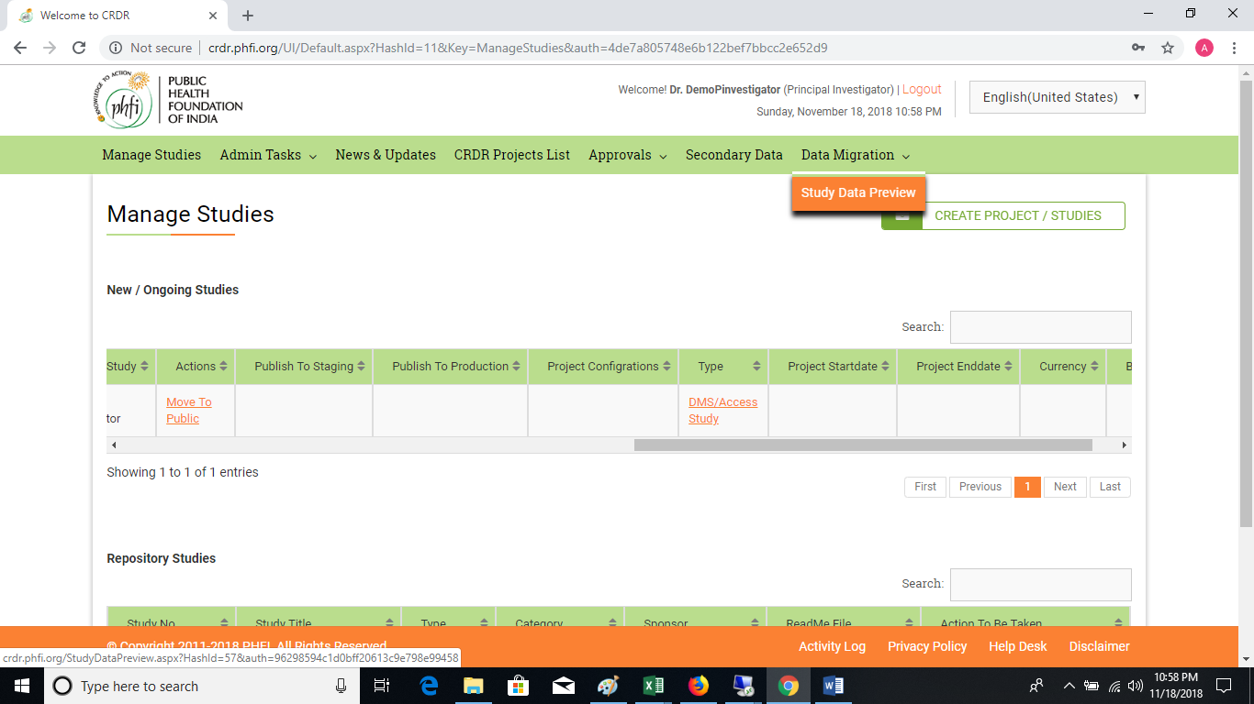

**Step 05:** Click open Study data preview**. You will have options to select the Study and respective study data table.**

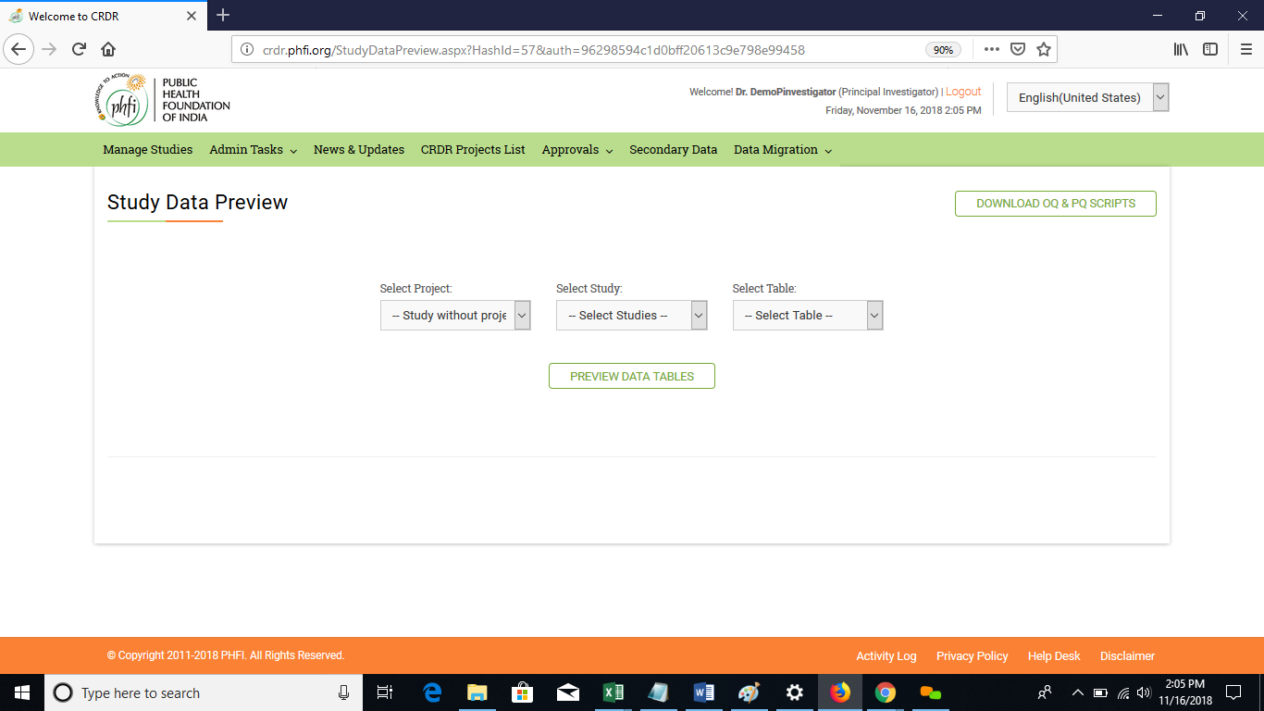  
**Step 06**: Choose the required table.

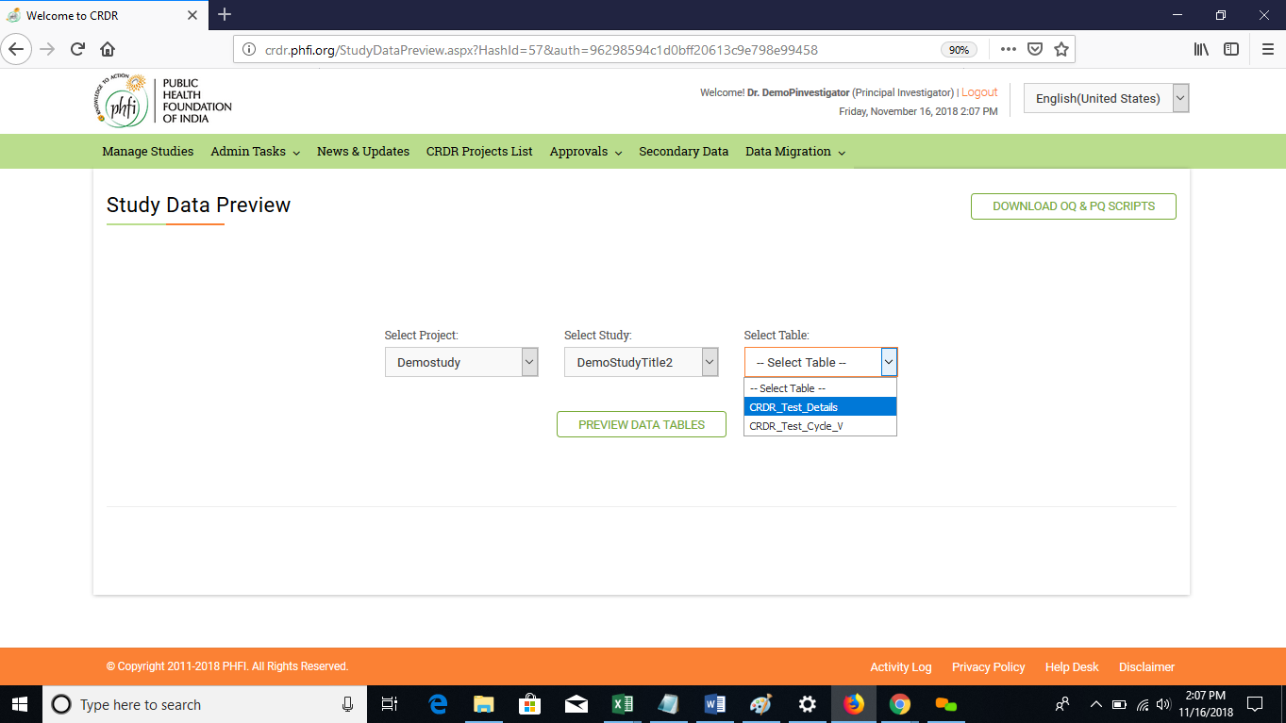

**Step 07**: Preview the data and you can also export the data. The code book attached to the study can be exported using “Export Code book” option.

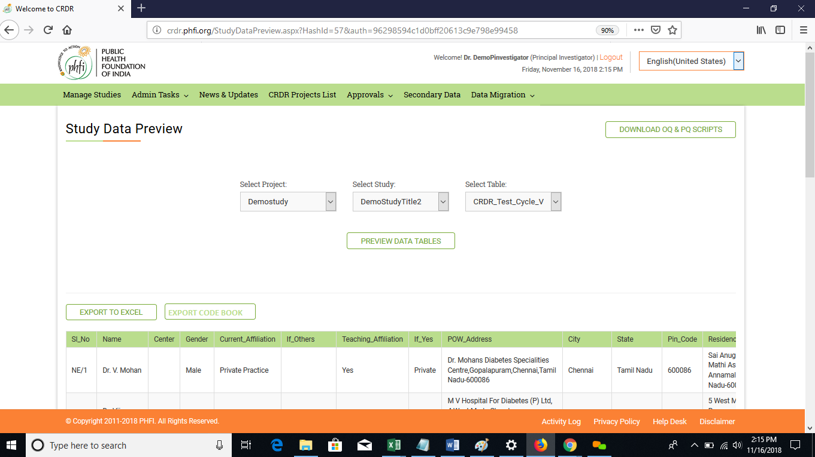

**Step 08**: If there is no study data migrated through data migration, then system displays the message “Data is not provided for this Study”.

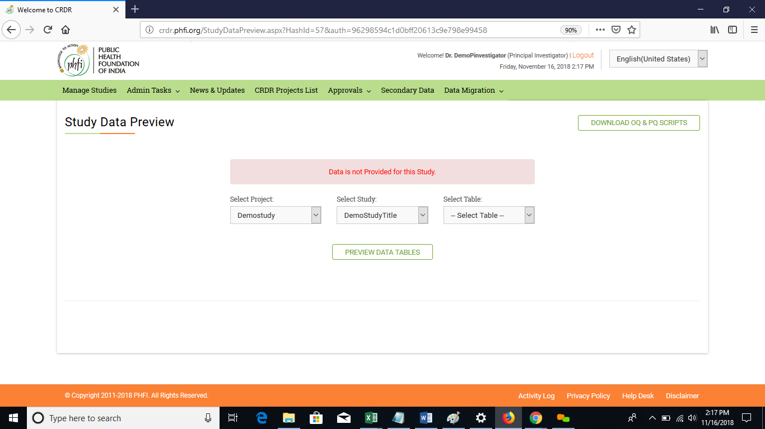

**Step 07:** Click on DMS/Access Study from step 03.System navigates you to a Study page where DMS is available as menu option on header.Click open DMS.

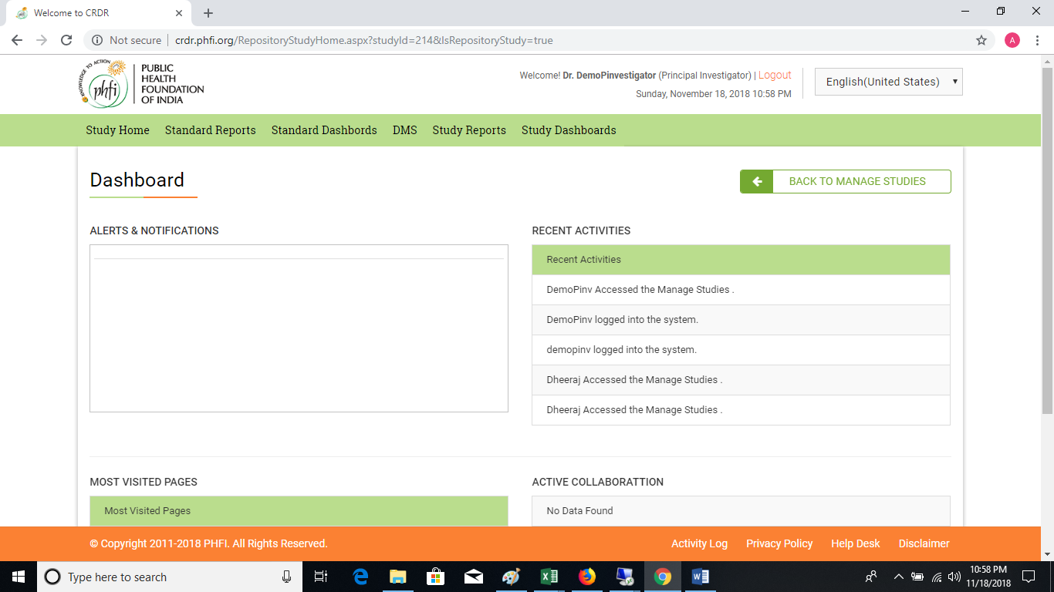

**Step 08:** All the documents will be available in the folder. Click open the folders or download the entire folder to download the documents in your local system. You can add the folders using “Create Folder” option.

Note: If you find only “Other documents” folder it means, documents are available only in that Folder and no other folders are represented for document upload.

